# OBSERVATIONS

| **Experiments** | **Model** | **Augmentation** | **No.of Parameters** | **Results** | **Decision + Explanation** |
| --- | --- | --- | --- | --- | --- |
| **mode1_experiment1** | **Conv3D** | **No** | **3,667,749** | **Training Accuracy: 40.58**  **Validation Accuracy: 37.5**  **Training Loss: 1.463Validation Loss: 1.63** | **Basic CNN model (3D) with 4 stacks of Conv3D layer, batch normalization and MaxPooling. Model stopped after the 11th epoch due to early stopping function. Since the no.of parameters are high, model size is also high (~44 Mb).** |
| **model1_experiment2** | **Conv3D** | **No** | **3,667,749** | **Training Accuracy: 71.61**  **Validation Accuracy: 78.33**  **Training Loss: 0.71 Validation Loss: 0.60** | **Changed the batch size to 40 to increase accuracy. Also, changed the learning rate to 0.002 to run all the epochs. Though the model is Underfitting, the loss is very good in both training and validation. So it can be acceptable.** |
| **model1_experiment3** | **Conv3D** | **No** | **3,667,749** | **Training Accuracy: 63.72**  **Validation Accuracy: 73**  **Training Loss: 0.76 Validation Loss: 0.81** | **Changed the batch size to 20 to check the alternate results of accuracy. Model is still Underfitting, but the validation loss has increased compared to previous observation. So, batch size 40 is to be preferred.** |
| **model2_experiment1** | **Conv3D** | **No** | **1,967,813** | **Training Accuracy: 31.88**  **Validation Accuracy: 25**  **Training Loss: 1.98 Validation Loss: 3.11** | **Changed the input frames to 16, increased the network filters by 8 in each layer, kept the kernel size as constant at (3,3,3), decreased the dense neurons to 256, changed the batch size to 30. Model gives bad results, but accuracy and loss are changing concurrently in training and validation metrics.** |
| **model2_experiment2** | **Conv3D** | **No** | **1,967,813** | **Training Accuracy: 40.58**  **Validation Accuracy: 47.5**  **Training Loss: 1.51 Validation Loss: 1.60** | **Changed the learning rate to 0.02 in optimizer to run all the epochs. The validation results have outscored the training results in both accuracy and loss, clearly indicating Underfitting. Model size is ~23Mb.** |
| **model3_experiment1** | **Conv3D** | **Yes** | **1,967,813** | **OOM error (Out of Memory). GPU RAM was 2GB.** | **Model is trained under augmented data. A mistake was made in the generator; resulting in doubling of batch size. After checking the tensor shape it showed that 11 GB was given input.** |
| **model4_experiment1** | **Conv3D** | **Yes** | **908,725** | **Training Accuracy: 29.41**  **Validation Accuracy: 37**  **Training Loss: 1.76 Validation Loss: 1.34** | **A new generator was built avoiding the previous mistakes. Kernel size was scaled down to (2,2,2) and batch size to 20, as a precaution of OOM error. Model was Underfitting consistently after 7 epochs. Model size is ~11 Mb.** |
| **model4_experiment2** | **Conv3D** | **Yes** | **908,725** | **Training Accuracy: 70.93**  **Validation Accuracy: 71.67**  **Training Loss: 0.77 Validation Loss: 0.65** | **Increased the batch size to 40 to increase accuracy. Increased no.of epochs to 25 to see more changes. The results are fluctuating in a streamline making this model with such less memory more consistent and reliable.** |
| **model4_experiment3** | **Conv3D** | **Yes** | **908,725** | **Training Accuracy: 33.33**  **Validation Accuracy: 50**  **Training Loss: 1.63 Validation Loss:1.77** | **Changed the batch size to 30 to compare and contrast the results. The model is clearly underfitting and the results are changing in parallel to each other in both accuracy and validation.** |
| **model4_experiment4** | **Conv3D** | **No** | **908,725** | **Training Accuracy: 75.09**  **Validation Accuracy: 25**  **Training Loss: 0.67 Validation Loss: 4.11** | **Model is trained with the previous regular generator with no augmentation for comparison. Batch size was increased to 40 which is optimal. The model is overfitting with a large difference and validation loss is the highest recorded one in the experiments.** |
| **model5_experiment1** | **Conv3D** | **Yes** | **699,269** | **Training Accuracy: 27.54**  **Validation Accuracy: 30**  **Training Loss: 1.65 Validation Loss: 1.48** | **Changed the kernel size to (3,3,3), decreased dense neurons to 64, and reduced the dropout to 0.25. The results indicate training loss is constant throughout the epochs, the training and validation accuracy are fluctuating, but not in accordance to each other.** |
| **model5_experiment2** | **Conv3D** | **Yes** | **699,269** | **Training Accuracy: 28.43**  **Validation Accuracy: 40**  **Training Loss: 1.69 Validation Loss: 1.48** | **Decreased batch size to 20, in hopes of making a concurrently changing accuracy. But the model stopped training after 11 epochs (early stopping), indicating that the loss will be increasing for a model with such batch size. Model file size is ~8 Mb.** |
| **model6_experiment1** | **Conv3D** | **Yes** | **387,573** | **Training Accuracy: 67.82**  **Validation Accuracy: 41.67**  **Training Loss: 0.85 Validation Loss: 1.80** | **Image size was downscaled to 100*100, kernel size was reduced to (2,2,2), dropout increased to 0.5 with batch size 40. With such low no.of parameters this model is the smallest model in size with ~5 Mb.** |
| **model7_experiment1** | **Conv3D** | **Yes** | **1,967,813** | **Training Accuracy: 24.64**  **Validation Accuracy: 25**  **Training Loss: 2.35 Validation Loss: 1.92** | **Image size is changed back to 120*120 and no.of dense neurons to 256. This model is similar to model 2 with the change in augmentation. The accuracy is fluctuating concurrently with significant differences.** |
| **model8_experiment1** | **Conv2D+LSTM** | **Yes** | **1,657,445** | **Training Accuracy: 24.64**  **Validation Accuracy: 30**  **Training Loss: 1.50 Validation Loss: 1.43** | **This model is a combination of CNN and RNN. CNN layers are 2D time distributed neurons stacked one over the other 5 times. An LSTM layer is joined with 128 neurons. From the trends of results we can see that there is no correlation between training, validation loss and accuracy.** |
| **model8_experiment2** | **Conv2D+LSTM** | **No** | **1,657,445** | **Training Accuracy: 63.32**  **Validation Accuracy: 70**  **Training Loss: 0.92 Validation Loss: 0.84** | **Changed the batch size to 40 which is ideal for the experimentation. Used the regular generator with no augmentation. The training and validation metrics are changing concurrently until the final 25th epoch. The trained model file size is 20 Mb.** |
| **model9_experiment1** | **Conv2D+GRU** | **Yes** | **1,346,405** | **Training Accuracy: 55.36**  **Validation Accuracy: 21.67**  **Training Loss: 1.11 Validation Loss: 2.29** | **This model is similar to CNN+LSTM with augmentation, but the batch size is kept at 40 to see the results at ideal conditions. The model was overfitting with no correlation between training and validation metrics. The model is stopped after 21 epochs indicating the loss will be increasing in plateau after that point.** |
| **model9_experiment2** | **Conv2D+GRU** | **No** | **1,346,405** | **Training Accuracy: 80.97**  **Validation Accuracy: 75**  **Training Loss: 0.50 Validation Loss: 0.85** | **Changed back to regular generator with no augmentation. Even though the model is overfitting thoroughly, these are the best metrics (both accuracy and loss) among all the observations. The trained model file size is ~16 Mb.** |

## Best model with no augmentation is model9_experiment2. (~16 Mb)

## Best model with augmentation is model4_experiment2 (~11 Mb). Since this model is smaller than the other, this is selected as the best among the experiments.

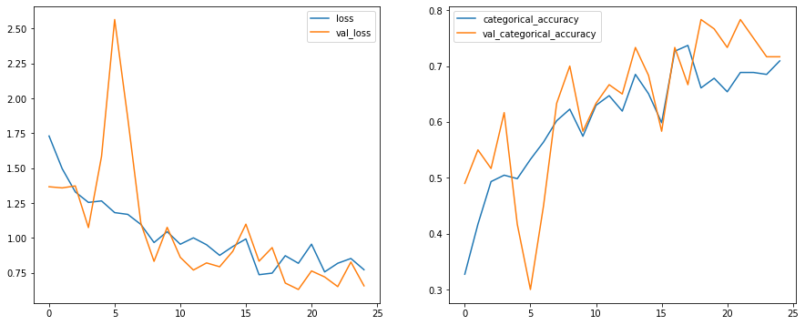

## The above graphs illustrate the Loss and Accuracy trade-off between training and validation metrics.